
AHMADU BELLO UNIVERSITY, ZARIA

FACULTY OF PHYSICAL SCIENCES

DEPARTMENT OF COMPUTER SCIENCE

DESIGN AND IMPLEMENTATION OF AN ELECTRONIC HELPDESK SYSTEM FOR DEPARTMENT OF COMPUTER SCIENCE, AHMADU BELLO UNIVERSITY, ZARIA

BY

KHALEEL IBRAHIM

U21CS1064

A PROJECT SUBMITTED TO THE DEPARTMENT OF COMPUTER SCIENCE, FACULTY OF PHYSICAL SCIENCES, AHMADU BELLO UNIVERSITY, ZARIA-NIGERIA IN PARTIAL FULFILMENT OF THE REQUIREMENTS FOR THE AWARD OF THE DEGREE OF BACHELOR OF SCIENCE (B. Sc. Hons.) IN COMPUTER SCIENCE

OCTOBER 2026

DECLARATION

I, Khaleel Ibrahim, hereby declare that this project titled Electronic Helpdesk System for the Department of Computer Science, Ahmadu Bello University, Zaria, has been carried out by me under the supervision of Mal. A.A Sambo. It has not been presented for the award of any degree in any institution. All sources of information are specifically acknowledged by means of reference.

……………………………………………. ………………………………………
Khaleel Ibrahim Date

CERTIFICATION

This project entitled Design and implementation of an Electronic Helpdesk System for the Department of Computer Science, Ahmadu Bello University, Zaria by Khaleel Ibrahim meets the requirements governing the award of the degree of Bachelor of Science in Computer Science and is approved for its contribution to knowledge and literary presentation.

-------------------------------------------------- -------------------------
Mal. A.A Sambo Date
Supervisor

-------------------------------------------------- -------------------------
Prof. A.F.D. Kana Date
Head of Department

External Examiner
Name: --------------------------------------------------- -------------------------
Signature: ----------------------------------------------- -------------------------
Date: ---------------------------------------------------

DEDICATION

This work is dedicated to Almighty Allah, the source of all wisdom and strength, whose grace sustained this research from inception to completion. It is also dedicated to my beloved family, whose unconditional support, prayers, and encouragement have been the bedrock of my academic journey.

ACKNOWLEDGEMENTS

All praise and glory belong to Almighty Allah for the strength, wisdom, and guidance that sustained this work throughout. The researcher wishes to express sincere gratitude to the project supervisor, Mal. A.A Sambo, for the invaluable guidance, constructive criticism, patience, and constant encouragement offered throughout the course of this work.

Appreciation is equally extended to the Head of Department, Prof. A.F.D. Kana, and all academic and non-academic staff of the Department of Computer Science, Ahmadu Bello University, Zaria, for creating an enabling academic environment. Special thanks also go to colleagues and classmates whose discussions and peer support contributed meaningfully to this research.

Finally, heartfelt appreciation is due to family members and friends for their moral support, encouragement, and patience throughout this period of study.

ABSTRACT

The manual process of handling student complaints in the Department of Computer Science, Ahmadu Bello University, Zaria, is characterised by delays, lack of transparency, and poor record-keeping, resulting in unresolved issues and student dissatisfaction. This project presents the design and development of a web-based Helpdesk Complaint Management System to address these challenges. The system was developed using PHP, MySQL, HTML, CSS, Bootstrap 5, and JavaScript, and runs on a standard XAMPP server environment. It provides students with a portal to register, submit complaints across six defined categories, and track the status of their complaints in real time. The administrative interface enables authorised personnel to view all submitted complaints, respond to students, and update complaint statuses. The system enforces session-based authentication, password hashing, and prepared SQL statements to ensure basic security. Testing confirmed that the system successfully handles complaint submission, status management, and administrative replies across all defined categories. The resulting platform eliminates the need for physical visits for routine complaints, establishes an auditable complaint trail, and significantly improves response time and communication between students and the department administration.

TABLE OF CONTENTS
Title Page i
Declaration ii
Certification iii
Dedication iv
Acknowledgements v
Abstract vi
Table of Contents vii
CHAPTER ONE: INTRODUCTION 1
1.1 Background to the Study 1
1.2 Problem Statement 1
1.3 Aim and Objectives 2
1.4 Scope of the Study 3
1.5 Significance of the Study 3
1.6 Organisation of the Report 4
CHAPTER TWO: LITERATURE REVIEW 5
2.1 Introduction 5
2.2 Concept of Helpdesk and Complaint Management Systems 5
2.3 Review of Related Works 5
2.3.1 Online Complaint Management System for Universities 5
2.3.2 Web-Based Student Complaint System for a Nigerian Polytechnic 6
2.3.3 E-Complaint System Using Laravel and Vue.js 6
2.3.4 Helpdesk Ticketing System for an ICT Department 6
2.3.5 Complaint Management System Using ASP.NET 6
2.3.6 Open-Source Helpdesk Platforms 7
2.4 Comparison of Related Systems 7
2.5 Limitations of Existing Systems 8
2.6 Summary 8
CHAPTER THREE: DESIGN OF THE PROPOSED SYSTEM 9
3.1 Introduction 9
3.2 System Requirements 9
3.2.1 Functional Requirements 9
3.2.2 Non-Functional Requirements 10
3.3 System Analysis 11
3.4 Use Case Diagram 11
3.5 Entity-Relationship (ER) Diagram 12
3.6 Activity Diagram 13
3.7 Database Design 14
3.7.1 students Table 14
3.7.2 admin Table 15
3.7.3 complaints Table 15
3.8 System Architecture 16
CHAPTER FOUR: IMPLEMENTATION OF THE PROPOSED SYSTEM AND DISCUSSION OF RESULTS 17
4.1 Introduction 17
4.2 Development Environment and Tools 17
4.3 System Implementation 18
4.3.1 System Landing Page 18
4.3.2 Student Registration 19
4.3.3 Student Login Page 20
4.3.4 Student Dashboard 21
4.3.5 Complaint Submission 22
4.3.6 Admin Login Page 24
4.3.7 Admin Dashboard 24
4.3.8 Security Implementation 26
4.4 System Testing 27
4.5 Discussion of Results 29
CHAPTER FIVE: SUMMARY, CONCLUSIONS AND RECOMMENDATIONS 31
5.1 Summary 31
5.2 Conclusions 31
5.3 Recommendations 32
REFERENCES 34
APPENDIX A: USER MANUAL 35
A.1 System Requirements 35
A.2 Installation Instructions 35
A.3 Student Guide 35
A.4 Administrator Guide 36
A.5 Default Admin Credentials 36

CHAPTER ONE
INTRODUCTION

1.1 Background to the Study

The management of student complaints in tertiary institutions is a critical administrative function that directly influences the quality of education and the relationship between students and institutional authorities. In many Nigerian universities, complaint handling is still carried out through informal, manual processes involving physical visits to departmental offices, verbal communication, or unstructured written petitions. These processes are frequently inefficient, non-transparent, and prone to the mismanagement of information, resulting in delayed resolutions and persistent student dissatisfaction.

The Department of Computer Science at Ahmadu Bello University (ABU), Zaria, lacks a structured electronic platform through which students can formally lodge complaints and track their resolution. Issues ranging from missing examination results and course registration errors to laboratory faults and lecturer-related concerns are routinely handled through informal channels, resulting in delays, loss of information, and considerable student frustration.

This project therefore proposes the design and development of a web-based Helpdesk Complaint Management System for the Department of Computer Science, ABU, Zaria, to replace the existing informal process with a structured, accessible, and efficient digital platform that benefits both students and the departmental administration (Laudon & Laudon, 2020).

1.2 Problem Statement

The existing complaint handling process in the Department of Computer Science, ABU, Zaria, is characterised by significant shortcomings. There is no formal, documented channel for students to submit complaints, making accountability and status tracking impossible. Complaints submitted verbally are frequently lost or unresolved due to the absence of permanent records. Students cannot follow up without physical visits, and the administration has no consolidated view of pending or resolved issues. There is therefore a clear and pressing need for a structured digital system to manage student complaints effectively and transparently.

1.3 Aim and Objectives

The aim of this project is to design and develop a web-based Helpdesk Complaint Management System for the Department of Computer Science, Ahmadu Bello University, Zaria, that provides students with a structured and transparent platform for submitting and tracking complaints, and equips the department administration with tools to manage and resolve those complaints efficiently.

The following specific objectives are pursued:

- To analyse the existing complaint handling process and identify its key limitations.
- To design a relational database structure for storing student, administrator, and complaint information securely.
- To develop a student-facing interface for registration, login, complaint submission, and real-time status tracking.
- To develop an administrative interface for viewing, replying to, and updating the status of complaints.
- To implement basic security measures including session management, bcrypt password hashing, and PDO prepared statements.
- To test the system against defined functional and non-functional requirements.

1.4 Scope of the Study

This study covers the design and development of a web-based electronic helpdesk complaint management system for the Department of Computer Science, ABU, Zaria. The system supports two user categories: registered students and a single departmental administrator. Students may submit complaints under six predefined categories (Results Issues, Course Registration, ICT/Lab Problems, Lecturer Complaints, Project/SIWES Issues, and Others) and view responses on a personal dashboard. The administrator may view all complaints, provide written replies, and update statuses. The system is developed for local XAMPP deployment. Features such as email notifications, file attachments, and multi-administrator support are outside the scope of this work.

1.5 Significance of the Study

For students, the system provides a convenient and transparent means of raising concerns without physical visits to the department office. For the administration, it provides a centralised complaint repository enabling organised and prioritised responses. The complaint history supports accountability and informs departmental policy improvements. The project also demonstrates the practical application of web development skills and contributes to knowledge on information systems in Nigerian university administration.

1.6 Organisation of the Report

This report is organised into five chapters. Chapter One presents the background, problem statement, aim, objectives, scope, and significance. Chapter Two reviews relevant literature and identifies gaps. Chapter Three describes the system design including requirements, UML diagrams, ER diagram, database design, and architecture. Chapter Four presents the implementation and test results. Chapter Five provides a summary, conclusions, and recommendations. References and appendices follow Chapter Five.

CHAPTER TWO
LITERATURE REVIEW

2.1 Introduction

This chapter reviews literature relevant to the development of a web-based helpdesk complaint management system. It examines the conceptual foundations of helpdesk systems, surveys related works, compares their features, and identifies the gaps the present work seeks to address.

2.2 Concept of Helpdesk and Complaint Management Systems

A helpdesk system is an information system designed to receive, process, track, and respond to user complaints in a structured and documented manner. Laudon and Laudon (2020) classify such systems as transaction processing systems that record routine interactions between institutions and their stakeholders. Turban, Pollard, and Wood (2018) describe them as a subcategory of customer relationship management (CRM) tools facilitating structured communication between service providers and clients. In an academic context, the department serves as the service provider and students as the clients. Core components include user authentication, complaint submission, categorisation, status tracking, and response mechanisms. Web-based implementations are particularly appropriate for academic environments due to their accessibility from any device (Date, 2004).

2.3 Review of Related Works

2.3.1 Online Complaint Management System for Universities

Sharma and Gupta (2019) developed an online complaint management system for an Indian university using PHP and MySQL. The system introduced a multi-tier administrative structure and reduced resolution time from three weeks to under five days. However, it lacked complaint categorisation and a student-facing status tracking dashboard.

2.3.2 Web-Based Student Complaint System for a Nigerian Polytechnic

Adeyemi and Okafor (2020) implemented a web-based complaint system for a Nigerian polytechnic using PHP, MySQL, and Bootstrap. It reduced resolution time from over two weeks to under three days but lacked complaint categorisation and individual status tracking for students.

2.3.3 E-Complaint System Using Laravel and Vue.js

Ibrahim and Musa (2021) developed an e-complaint system using Laravel and Vue.js. It offered role-based access control and email notifications but required Composer, npm, and a configured mail server, making it unsuitable for resource-constrained environments.

2.3.4 Helpdesk Ticketing System for an ICT Department

Aliyu and Danladi (2022) implemented a Django/SQLite-based ticketing system for a university ICT unit. It was designed for staff-to-staff workflows and did not support student-facing complaint submission, limiting its applicability to the present context.

2.3.5 Complaint Management System Using ASP.NET

Eze and Nwosu (2020) presented an ASP.NET/SQL Server complaint system for a Nigerian state university. While functional, it required Windows Server and IIS infrastructure not available in the XAMPP-based target environment of this project.

2.3.6 Open-Source Helpdesk Platforms

Platforms such as osTicket, Freshdesk, and Zendesk offer comprehensive helpdesk features (osTicket, 2023). However, they are general-purpose, require significant customisation, and are either subscription-based or require complex setup, making them unsuitable for a lightweight single-department deployment.

2.4 Comparison of Related Systems

Table 2.1 presents a structured comparison of the reviewed systems against the key features required by the proposed system.

Table 2.1: Comparison of Related Systems
System / Study | Web-Based | Categorisation | Status Tracking | Admin Reply | Student Dashboard | Simple Stack
Sharma & Gupta (2019) | Yes | No | No | Yes | No | Yes
Adeyemi & Okafor (2020) | Yes | No | Yes | Yes | No | Yes
Ibrahim & Musa (2021) | Yes | Yes | Yes | Yes | Yes | No
Aliyu & Danladi (2022) | Yes | Yes | Yes | Yes | No | No
Eze & Nwosu (2020) | Yes | No | Yes | Yes | No | No
osTicket / Freshdesk | Yes | Yes | Yes | Yes | Yes | No
Proposed System | Yes | Yes | Yes | Yes | Yes | Yes
(Source: Author's compilation, 2025)

2.5 Limitations of Existing Systems

- Most systems were designed for general institutional use and lack complaint categories specific to a computer science department.
- Several systems provided no student dashboard for tracking complaint status after submission.
- Systems built on Laravel, Django, and ASP.NET are unnecessarily complex for straightforward academic complaint workflows.
- Commercial platforms are disproportionately complex and costly for single-department deployment.
- None of the reviewed systems were built specifically for the Department of Computer Science, ABU, Zaria.

2.6 Summary

The literature review establishes that web-based complaint management systems have been widely studied and implemented with consistent benefits in reducing resolution time and improving communication. However, a gap exists in the availability of a lightweight, department-specific system for the Department of Computer Science, ABU, Zaria. The present work addresses this gap using plain PHP, MySQL, Bootstrap 5, and vanilla JavaScript, incorporating complaint categorisation, a student status tracking dashboard, and administrator reply functionality within a single, maintainable codebase.

CHAPTER THREE
DESIGN OF THE PROPOSED SYSTEM

3.1 Introduction

This chapter presents the design of the proposed web-based Electronic Helpdesk Complaint Management System. It covers requirements analysis, UML diagrams (Use Case and Activity diagrams), an Entity-Relationship (ER) diagram, database design, and system architecture. All design decisions are grounded in the objectives established in Chapter One and the limitations identified in Chapter Two.

3.2 System Requirements

System requirements define what the system must do (functional requirements) and the quality attributes it must exhibit (non-functional requirements), derived from analysis of the shortcomings of the existing manual process.

3.2.1 Functional Requirements

Table 3.1 presents the functional requirements of the proposed system.

Table 3.1: Functional Requirements of the Proposed System
FR No. | Requirement | Description
FR-01 | Student Registration | The system shall allow students to register using full name, email, matric number, and password.
FR-02 | Student Login | The system shall authenticate students using email and password via PHP session management.
FR-03 | Complaint Submission | The system shall allow authenticated students to submit complaints with a title, category, and description.
FR-04 | Complaint Categories | The system shall support six categories: Results Issues, Course Registration, ICT/Lab Problems, Lecturer Complaints, Project/SIWES Issues, and Others.
FR-05 | Status Tracking | The system shall display complaint status (Pending, In Progress, or Resolved) on the student dashboard.
FR-06 | View Admin Reply | The system shall display the administrator's reply alongside each complaint on the student dashboard.
FR-07 | Admin Login | The system shall authenticate the administrator through a dedicated login page.
FR-08 | View All Complaints | The system shall display all complaints to the administrator with student details, category, and date.
FR-09 | Admin Reply | The system shall allow the administrator to submit a written reply to any complaint.
FR-10 | Status Update | The system shall allow the administrator to update complaint status.
FR-11 | Complaint Filtering | The system shall allow the administrator to filter complaints by status.
FR-12 | Session Management | The system shall maintain authenticated sessions and redirect unauthenticated users to the login page.
FR-13 | Logout | The system shall allow both users to terminate their sessions securely.

3.2.2 Non-Functional Requirements

Table 3.2 presents the non-functional requirements of the proposed system.

Table 3.2: Non-Functional Requirements of the Proposed System
Attribute | Requirement
Usability | The interface shall be intuitive and responsive across desktop, tablet, and mobile devices using Bootstrap 5.
Security | Passwords shall be stored using bcrypt hashing. All queries shall use PDO prepared statements. Session checks shall protect all authenticated pages.
Reliability | The system shall correctly process and store all complaint data without loss under normal operating conditions.
Performance | All pages shall load within acceptable response time on a local XAMPP server under typical usage.
Maintainability | Source code shall use plain PHP with inline comments, structured in a minimal file layout for easy modification.
Portability | The system shall deploy on any standard LAMP or XAMPP stack without frameworks, package managers, or build tools.

3.3 System Analysis

The system supports two user categories. Students register with academic credentials, log in, access a personal dashboard showing their complaint history with statuses and admin replies, and submit new complaints by selecting a category and providing a title and description. The administrator logs in through a dedicated page, views all complaints from all students on a centralised dashboard with status filter options, provides written replies, and updates complaint statuses. The administrator account is pre-seeded in the database and is not accessible through any public registration interface.

3.4 Use Case Diagram

A Use Case Diagram is a UML behavioural diagram that illustrates the interactions between system actors and the system's functional use cases, providing a high-level visual representation of system functionality from the user's perspective (Rumbaugh, Jacobson & Booch, 2004). The CS Helpdesk System has two actors Student and Administrator and eleven use cases. Fig. 3.1 presents the Use Case Diagram.

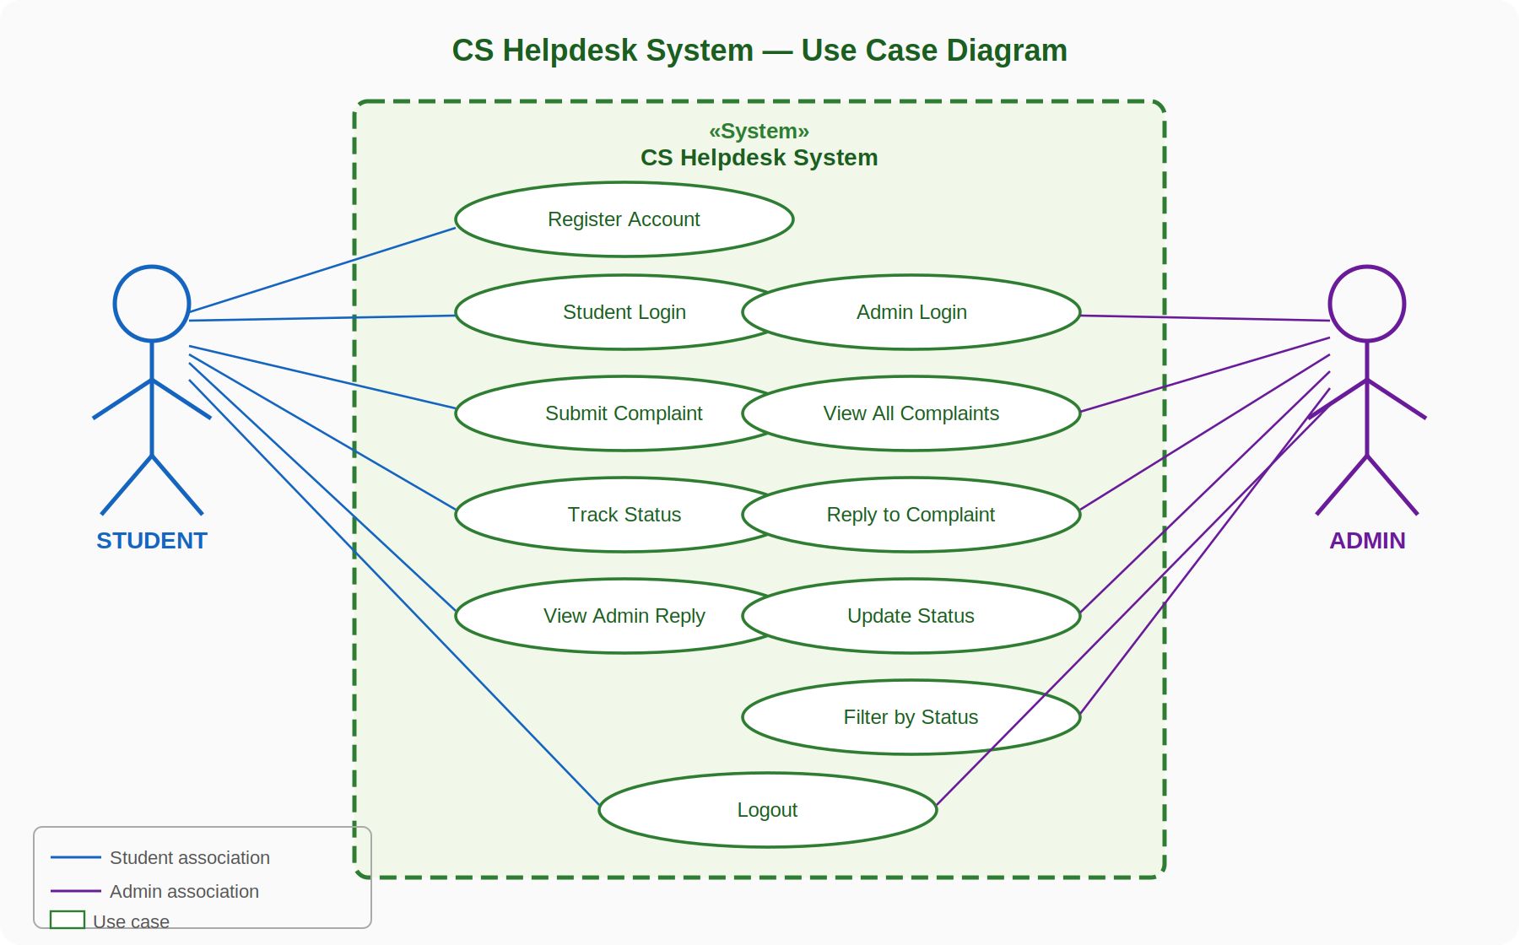
Fig. 3.1: Use Case Diagram

3.5 Entity-Relationship (ER) Diagram

An Entity-Relationship (ER) Diagram is a structural diagram used in database design to represent the entities within a system, their attributes, and the relationships between them (Date, 2004). The CS Helpdesk System comprises three entities: Students, Complaints, and Admin. One Student submits many Complaints (1:N); one Admin manages many Complaints (1:N). The student_id field in the Complaints table serves as a foreign key referencing the Students table, enforcing referential integrity with ON DELETE CASCADE. Fig. 3.2 presents the ER Diagram.

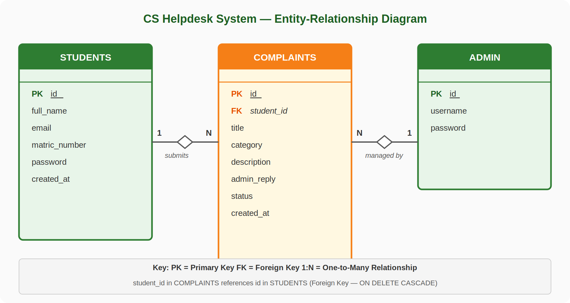
Fig. 3.2: Entity-Relationship (ER) Diagram

3.6 Activity Diagram

An Activity Diagram is a UML behavioural diagram that models the dynamic flow of control through a sequence of activities and decision points within a process (Rumbaugh et al., 2004). Fig. 3.3 presents the Activity Diagram for the student complaint submission workflow, the primary workflow of the system from initial login through to receipt of an administrative response.

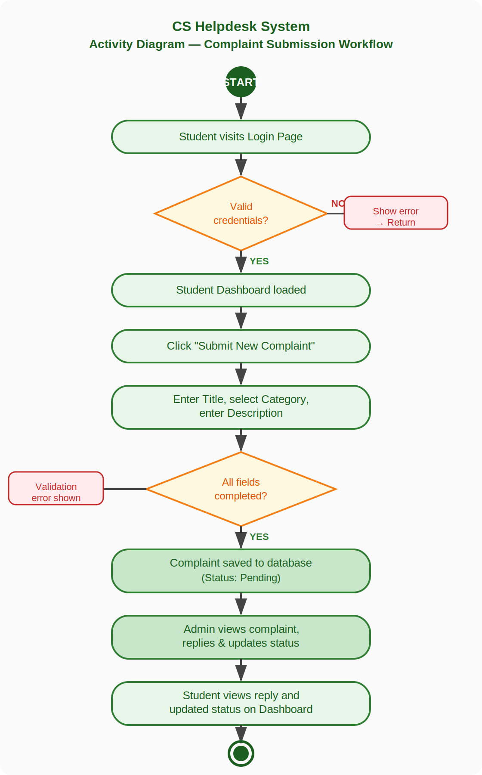
Fig. 3.3: Activity Diagram of Student Complaint Submission Workflow

3.7 Database Design

The database is implemented in MySQL and comprises three tables. The foreign key in the complaints table links to the students table, ensuring data integrity.

3.7.1 students Table

Table 3.3: Structure of the students Table
Field | Data Type | Constraint | Description
id | INT | PK, AUTO_INCREMENT | Unique student identifier
full_name | VARCHAR(100) | NOT NULL | Student's full name
email | VARCHAR(100) | UNIQUE, NOT NULL | Student's email address
matric_number | VARCHAR(20) | UNIQUE, NOT NULL | Student's matric number
password | VARCHAR(255) | NOT NULL | Bcrypt-hashed password
created_at | DATETIME | DEFAULT NOW() | Account registration timestamp

3.7.2 admin Table

Table 3.4: Structure of the admin Table
Field | Data Type | Constraint | Description
id | INT | PK, AUTO_INCREMENT | Unique admin identifier
username | VARCHAR(50) | UNIQUE, NOT NULL | Administrator login username
password | VARCHAR(255) | NOT NULL | Bcrypt-hashed admin password

3.7.3 complaints Table

Table 3.5: Structure of the complaints Table
Field | Data Type | Constraint | Description
id | INT | PK, AUTO_INCREMENT | Unique complaint identifier
student_id | INT | FK → students(id) | References the submitting student
title | VARCHAR(200) | NOT NULL | Brief complaint title
category | VARCHAR(100) | NOT NULL | Complaint category (one of six)
description | TEXT | NOT NULL | Full complaint description
admin_reply | TEXT | DEFAULT NULL | Administrator's written reply
status | ENUM | DEFAULT 'Pending' | Pending / In Progress / Resolved
created_at | DATETIME | DEFAULT NOW() | Complaint submission timestamp

3.8 System Architecture

The proposed system follows a three-tier web application architecture. The Presentation Layer handles the user interface using HTML, CSS, Bootstrap 5, and JavaScript rendered in the browser. The Application Layer contains the server-side business logic using PHP 7.4, PDO prepared statements, session management, input validation, and bcrypt password hashing, hosted on Apache via XAMPP. The Data Layer stores all data in a MySQL relational database comprising the three tables described above. Fig. 3.4 illustrates this architecture.

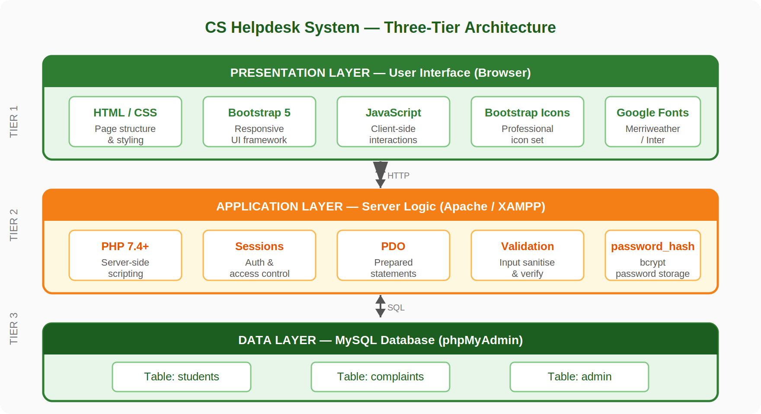
Fig. 3.4: Three-Tier System Architecture Diagram

CHAPTER FOUR
IMPLEMENTATION OF THE PROPOSED SYSTEM AND DISCUSSION OF RESULTS

4.1 Introduction

This chapter presents the implementation of the Electronic Helpdesk System For Department Of Computer Science. It describes the development environment and tools used, the implemented system interfaces, functional testing results, and a discussion of the findings.

4.2 Development Environment and Tools

The system was developed and tested locally using the following tools:

- Operating System: Windows 10 (64-bit)
- Web Server: Apache 2.4 via XAMPP Control Panel v3.3.0
- Database Server: MySQL 5.7 on port 3307 via XAMPP
- Server-Side Language: PHP 7.4
- Database Interface: PDO (PHP Data Objects) with prepared statements
- Front End Framework: Bootstrap 5.3 (CDN)
- Icon Library: Bootstrap Icons 1.11 (CDN)
- Code Editor: Visual Studio Code
- Database Administration: phpMyAdmin (bundled with XAMPP)
- Typography: Google Fonts Merriweather for headings, Inter for body text
- Browser Used for Testing: Google Chrome

No third-party PHP frameworks, Composer packages, or npm build tools were used in the development of this system. All PHP files are self-contained with direct database interaction via PDO, making the codebase straightforward to deploy, understand, and maintain without requiring additional infrastructure or tooling beyond a standard XAMPP installation.

4.3 System Implementation

The complete system comprises eleven PHP files, one custom CSS stylesheet (style.css), one SQL schema file (helpdesk.sql), and an images directory containing the ABU logo. Every page is fully responsive, adapting correctly to desktop, tablet, and mobile screen sizes through the use of Bootstrap 5's grid system and responsive utility classes. The following subsections describe each implemented page in detail, accompanied by a screenshot of that page as it appears in the browser during operation.
4.3.1 System Landing Page

The landing page serves as the entry point to the CS Helpdesk System. It displays the Ahmadu Bello University logo, the system name, and a brief description of its purpose. Two primary call to action buttons are presented: "Register Now" for new students who do not yet have an account, and "Student Login" for returning users. A smaller link at the bottom of the page directs the departmental administrator to the separate admin login page. The landing page uses a full-height green gradient background derived from the ABU brand identity, providing a professional and recognisable first impression consistent with the university's visual identity. No authentication is required to access this page.

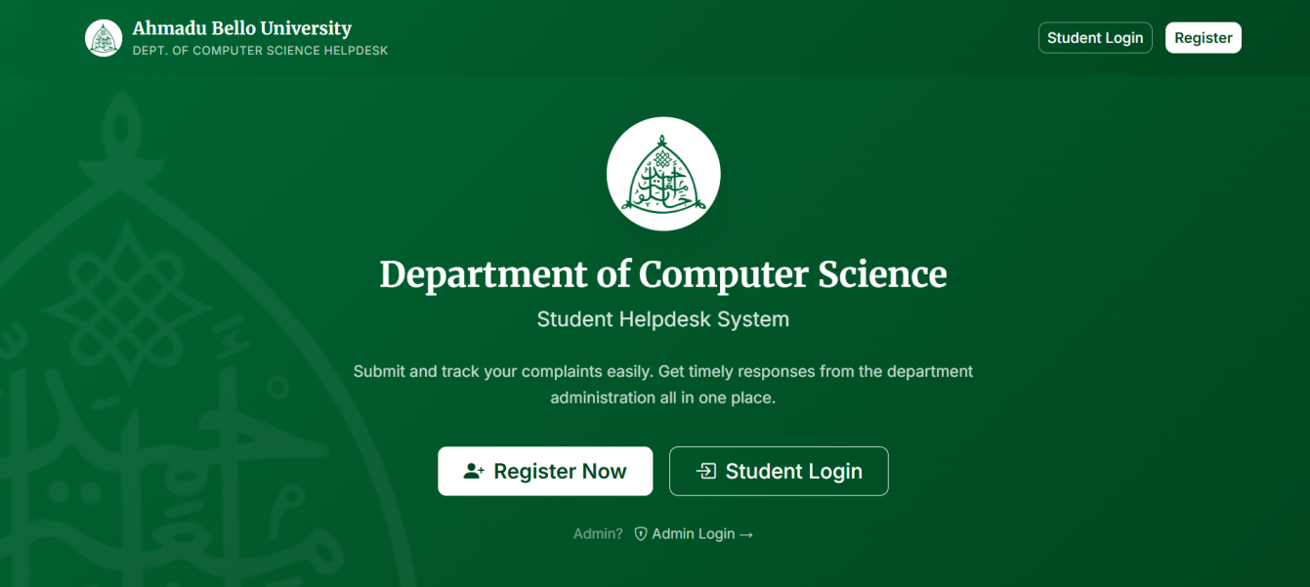
Fig. 4.1: System Landing Page

4.3.2 Student Registration

The student registration page allows new students to create an account on the system. The registration form collects four pieces of information: the student's full name, institutional email address, matric number, and a chosen password which must be confirmed in a second field. All fields are validated server-side before the record is inserted into the database. The system checks that no field is left empty, that the email address conforms to a valid format using PHP's filter_var() function, that the password and confirmation field match, and that the password is at least six characters in length. Before inserting the new record, a PDO prepared statement queries the students table to check whether the submitted email address or matric number already exists, preventing duplicate registrations. If validation fails for any reason, an inline error message is displayed at the top of the form specifying the exact issue. Upon successful registration, a success message is shown with a link directing the student to the login page.

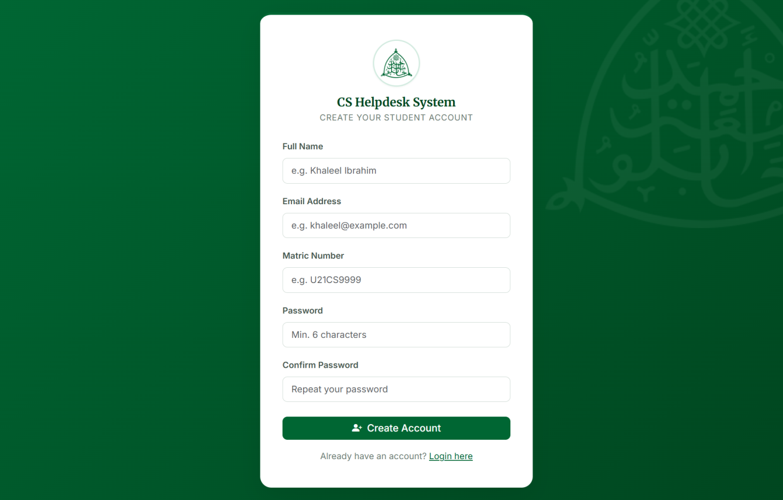
Fig. 4.2: Student Registration Page

4.3.3 Student Login Page

The student login page provides the authentication interface for registered students. The form accepts two inputs: the student's registered email address and password. Upon submission, the system retrieves the matching student record from the students table using a PDO prepared statement filtered by email address. The submitted password is then verified against the stored bcrypt hash using PHP's password_verify() function. If the credentials are valid, the student's ID and full name are stored in a PHP session variable and the user is redirected to the student dashboard. If authentication fails for any reason whether the email is not found or the password does not match, a single generic error message is displayed, reading "Invalid email or password." This intentionally avoids revealing which specific field was incorrect, reducing the risk of user enumeration. A link to the registration page is provided for users who do not yet have an account.

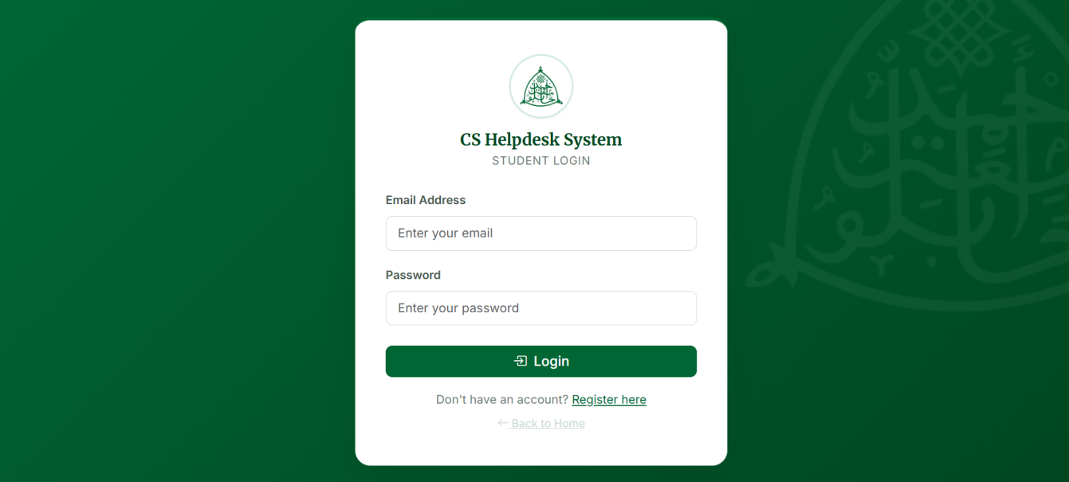
Fig. 4.3: Student Login Page

4.3.4 Student Dashboard

The student dashboard is the central interface for authenticated students and the first page displayed after a successful login. It is protected by a session check at the top of the file; any attempt to access it without an active session redirects the user to the login page immediately. The dashboard is organised into two main sections. The first section, displayed at the top of the page, consists of four summary statistic cards showing: the total number of complaints submitted by the logged in student, the number of complaints currently with a status of "Pending", the number with a status of "In Progress", and the number with a status of "Resolved". These cards are colour coded amber for Pending, blue for In Progress, and green for Resolved enabling the student to assess the overall state of their complaints at a glance. The second section presents a responsive table listing all complaints submitted by the student, ordered by submission date from most recent to oldest. Each row in the table displays the complaint title and a brief excerpt of the description, the complaint category, the current status badge, the submission date, and the full text of the administrator's reply if one has been provided. If no reply has been submitted yet, the cell reads "Awaiting reply." A button in the top right corner of the complaints card allows the student to navigate directly to the complaint submission page.

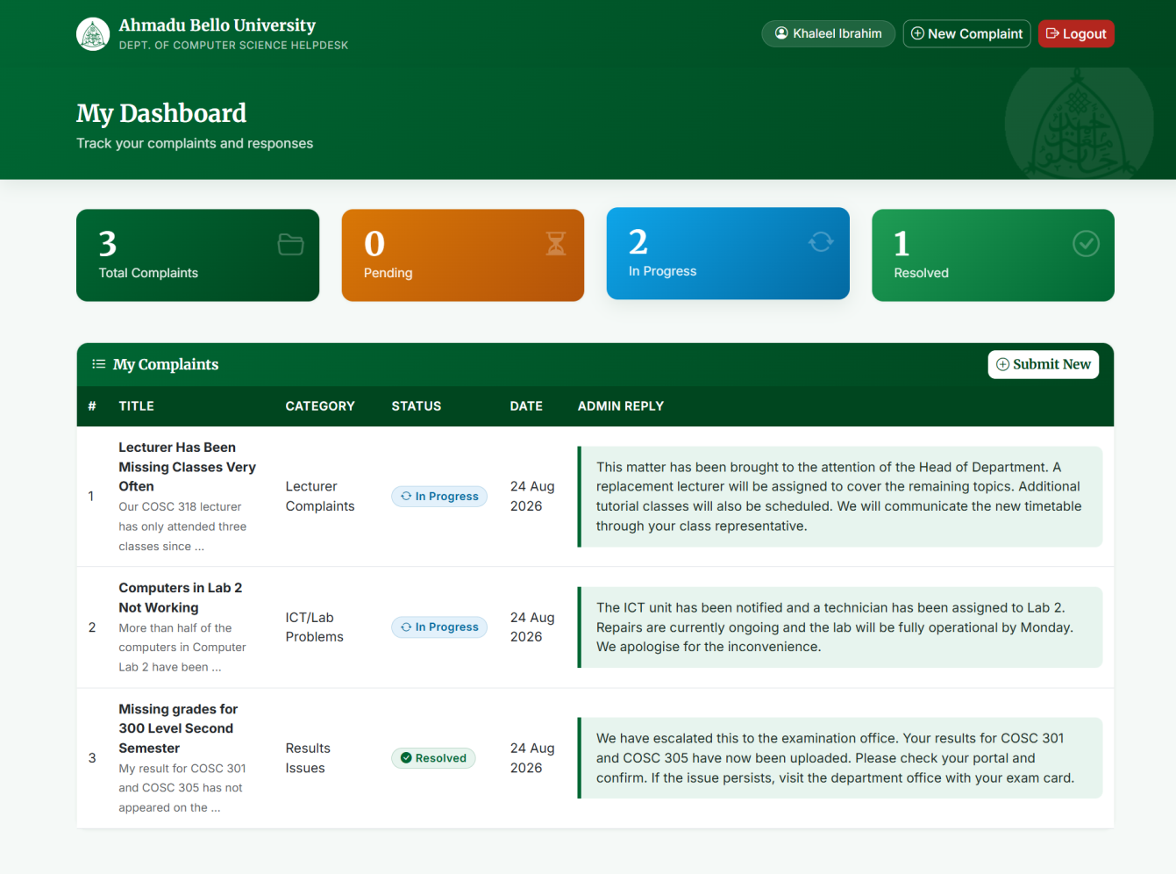
Fig. 4.4: Student Dashboard Overview with stat cards and complaint table

4.3.5 Complaint Submission

The complaint submission page allows an authenticated student to formally lodge a new complaint with the department. This page is also session protected and redirects unauthenticated users to the login page. The submission form contains three input elements. The first is a text input field for the complaint title, which should be a concise description of the issue for example, "Missing Result for COSC353" or "Lab Computer Not Working." The second is a dropdown select element presenting the six predefined complaint categories: Results Issues, Course Registration, ICT/Lab Problems, Lecturer Complaints, Project/SIWES Issues, and Others. The category is validated server-side against the predefined list to prevent the insertion of arbitrary values, even if a user were to manipulate the form data. The third element is a multi-line textarea for the full description of the complaint, where the student is encouraged to be as specific and detailed as possible to assist the administrator in resolving the issue efficiently. All three fields are required, submitting the form with any field empty triggers a validation error message. Upon successful submission, a success confirmation message is displayed and the complaint is inserted into the complaints table with the student's ID, the current timestamp, and a default status of "Pending." A link to the dashboard is provided so the student can immediately see their new complaint listed.
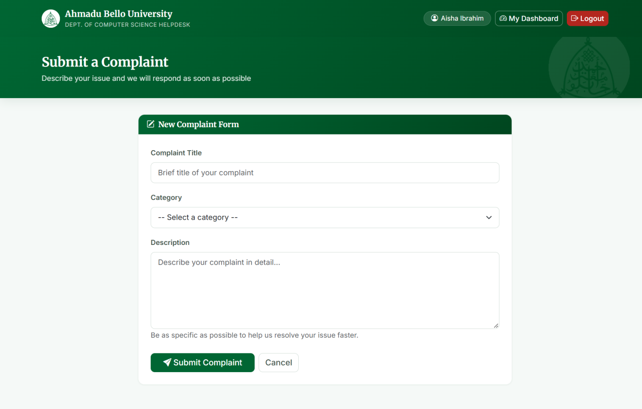
Fig. 4.5: Complaint Submission Page form

4.3.6 Admin Login Page

The administrator login page provides a separate, dedicated authentication interface for the departmental administrator. It is accessible via a direct URL (admin_login.php) or through the small link on the system landing page, and is visually distinct from the student login page through the use of a shield lock icon and the label "CS Helpdesk Administration." The login form accepts a username and password. Upon submission, the system queries the admin table using a PDO prepared statement to retrieve the record matching the submitted username. The stored password field is then examined: if it is a bcrypt hash (identified by its length and the $2y$ prefix), PHP's password_verify() function is used for verification. Upon successful authentication, the administrator's ID and username are stored in a PHP session and the user is redirected to the admin dashboard.

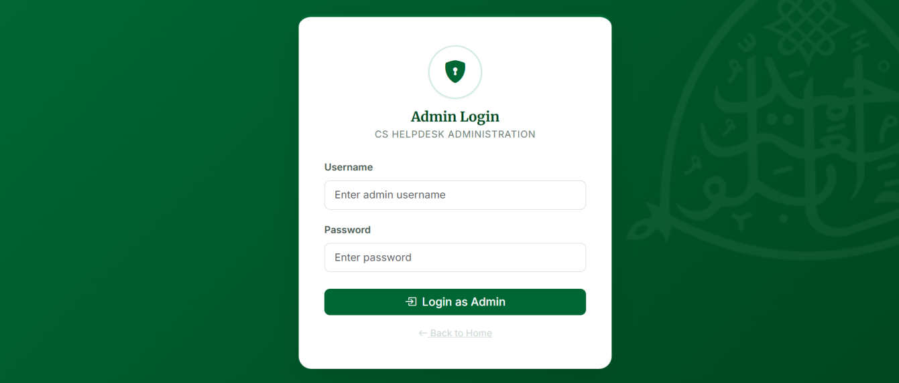
Fig. 4.6: Administrator Login Page

4.3.7 Admin Dashboard

The administrator dashboard is the primary interface for the departmental administrator and is protected by its own session check. Any attempt to access it without an active admin session redirects to the admin login page. The dashboard opens with four summary statistic cards at the top of the page, displaying the total number of complaints submitted across all students, and individual counts for Pending, In Progress, and Resolved complaints. These cards use the same colour scheme as the student dashboard for consistency. Below the statistics, a row of filter buttons allows the administrator to narrow the displayed complaints to a specific status category: All, Pending, In Progress, or Resolved. The active filter button is highlighted to indicate the current view. The main body of the dashboard presents every complaint as an individual card. Each card is divided into two columns: the left column displays the complaint details including the student's full name, matric number, email address, the complaint title, category badge, full description text, current status badge, and the submission date and time. If the administrator has previously submitted a reply, the existing reply text is shown in a highlighted callout box at the bottom of the left column. The right column contains an inline management form that allows the administrator to type or update a reply in a textarea and select a new status from a dropdown before clicking "Update Complaint" to save changes. All status values submitted through this form are validated server-side against the allowed enumeration values before the database record is modified.

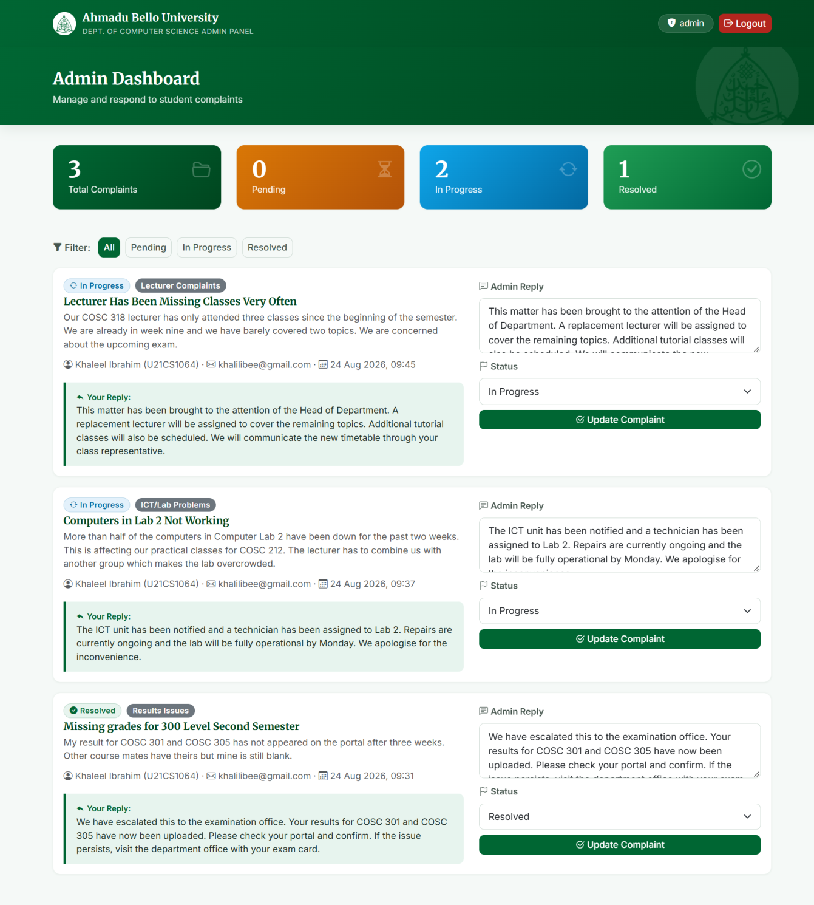
Fig. 4.7: Admin Dashboard full view showing all complaints, stat cards, and filter buttons

4.3.8 Security Implementation

Three layers of basic security are implemented consistently throughout all pages and database interactions of the system.

The first layer is password security. All student and administrator passwords are stored in the database as bcrypt hashes generated using PHP's password_hash() function with the PASSWORD_DEFAULT constant, which currently maps to the bcrypt algorithm. Plain-text passwords are never stored or logged at any point. Password verification during login uses PHP's password_verify() function, which performs a constant time comparison to prevent timing attacks.

The second layer is SQL injection prevention. Every database query throughout the system uses PDO (PHP Data Objects) prepared statements with parameterised placeholders. User supplied input values are never concatenated directly into SQL query strings. This ensures that malicious input such as SQL injection payloads cannot alter the structure or logic of any database query, regardless of what data the user submits through any form field.

The third layer is session based access control. Every protected page (dashboard.php, submit_complaint.php, and admin_dashboard.php) begins with a check for the presence of the appropriate session variable. If the expected session variable is absent or invalid indicating that the user has not authenticated, has logged out, or is attempting to access a page they are not authorised for the page immediately redirects the user to the appropriate login page using PHP's header() function followed by exit(), preventing any further code execution. This ensures that no protected content or functionality is accessible to unauthenticated users under any circumstances.

4.4 System Testing

Manual functional testing was conducted following the implementation of all system features to verify that the system behaves correctly in response to valid inputs, invalid inputs, and boundary conditions. Sixteen test cases were designed to cover all thirteen functional requirements defined in Chapter Three. For each test case, the test objective, the specific input applied, the expected system output, and the actual result observed during testing were recorded. Table 4.1 presents the complete set of test cases and their outcomes.

Table 4.1: System Test Cases and Results
TC No. | Test Objective | Input Applied | Expected Output | Result
TC-01 | Registration — valid data | All fields correctly completed | Account created; success message shown | PASS
TC-02 | Registration — duplicate matric | Existing matric number submitted | Error: already registered | PASS
TC-03 | Registration — password mismatch | Different password and confirm values | Error: passwords do not match | PASS
TC-04 | Registration — short password | Four-character password submitted | Error: minimum 6 characters | PASS
TC-05 | Student login — valid credentials | Correct email and password | Session created; redirected to dashboard | PASS
TC-06 | Student login — wrong password | Correct email, incorrect password | Error: invalid email or password | PASS
TC-07 | Unauthenticated dashboard access | Direct URL visit to dashboard.php | Redirected to student login page | PASS
TC-08 | Complaint submission — all fields | Title, category, and description provided | Complaint saved; visible on dashboard | PASS
TC-09 | Complaint submission — empty field | Description field left blank | Validation error; complaint not saved | PASS
TC-10 | Admin login — valid credentials | Correct username and password | Session created; redirected to admin dashboard | PASS
TC-11 | Admin login — invalid credentials | Wrong username or password | Error: invalid username or password | PASS
TC-12 | Admin reply and status update | Reply entered; status set to Resolved | Complaint updated; reply visible to student | PASS
TC-13 | Complaint filter by status | In Progress filter selected | Only In Progress complaints displayed | PASS
TC-14 | Student logout | Logout button clicked | Session destroyed; redirected to login page | PASS
TC-15 | Admin logout | Logout button clicked | Session destroyed; redirected to admin login page | PASS
TC-16 | SQL injection attempt | 'OR 1=1 -- entered in login field | Prepared statement blocks injection; login fails | PASS

4.5 Discussion of Results

All sixteen test cases returned a PASS result, confirming that the system correctly implements all thirteen functional requirements. Session-based access control successfully prevents unauthenticated access to protected pages. Password hashing and verification function correctly.
The complaint submission workflow correctly rejects incomplete submissions and invalid category values. Status updates and admin replies submitted through the admin dashboard are immediately reflected on the student dashboard. The SQL injection test confirmed that PDO prepared statements block malicious input at the database layer.

Two limitations were observed. First, the system does not send email notifications to students when their complaint status is updated, students must log in to check for responses. Second, the single administrator account limits the system to departments with one designated administrator. Both limitations are addressed in the recommendations in Chapter Five.

CHAPTER FIVE
SUMMARY, CONCLUSIONS AND RECOMMENDATIONS

5.1 Summary

This project designed and developed a web-based Helpdesk Complaint Management System for the Department of Computer Science, Ahmadu Bello University, Zaria. The work was motivated by the absence of a formal, transparent complaint-handling channel, which resulted in delayed resolutions, poor record-keeping, and student dissatisfaction.

The literature review in Chapter Two identified a gap in the availability of a lightweight, department-specific system using a simple PHP and MySQL stack. Chapter Three presented a comprehensive design including functional and non-functional requirements (Tables 3.1 and 3.2), a UML Use Case Diagram (Fig. 3.1) covering two actors and eleven use cases, an Entity-Relationship Diagram (Fig. 3.2) modelling the three-table relational database, an Activity Diagram (Fig. 3.3) illustrating the complaint submission workflow, and a three-tier system architecture (Fig. 3.4).

Chapter Four documented the implementation using PHP 7.4, MySQL 5.7, Bootstrap 5.3, and Bootstrap Icons on an Apache/XAMPP server. Sixteen functional test cases were executed, all returning a PASS result, confirming that all defined requirements were correctly met.

5.2 Conclusions

The development of this system demonstrates that a functional, usable, and secure web-based complaint management system can be built without complex frameworks, package managers, or advanced architectural patterns. The use of plain PHP with PDO, MySQL, Bootstrap 5, and vanilla JavaScript is sufficient to implement all core requirements in a manner that is maintainable, portable, and accessible to users with basic computer literacy.

The system addresses all identified problems of the existing manual process by providing permanent digital records of all complaints, transparent status tracking accessible at any time, and structured written communication between students and the administration. All functional requirements were verified through testing, and the system performed correctly in all scenarios. The project therefore meets its stated aim and objectives and represents a meaningful improvement over the current informal process.

5.3 Recommendations

Based on findings and limitations observed during development and testing, the following enhancements are recommended for future development:

- Email Notifications: The system should send automatic email alerts to students when the administrator replies or updates the status of their complaint, eliminating the need for repeated dashboard logins.
- Multi-Administrator Support: Role-based access control should be implemented to allow multiple staff members such as an HOD, Examination Officer, and ICT Coordinator to manage complaints within their designated categories.
- File Attachment Support: Students should be permitted to attach supporting documents or screenshots to their complaints to provide better evidence for administrators.
- Search and Pagination: As complaint volumes grow, the admin dashboard should incorporate search functionality and paginated results for efficient navigation.
- Complaint Analytics: A reporting module showing complaint volumes by category, average resolution times, and semester trends would help the department identify systemic issues and measure administrative performance.
- Online Deployment: The system should be deployed on a publicly accessible server to make it available to students from off campus, removing the current restriction to local network access only.
- Automated Testing Suite: Unit and integration tests should be developed to improve the reliability and safety of future maintenance updates and feature additions.

REFERENCES
Adeyemi, T. O., & Okafor, C. N. (2020). Design and implementation of a web-based student complaint management system for polytechnics in Nigeria. Journal of Information Technology and Computer Science, 5(2), 45–58.
Aliyu, M., & Danladi, S. A. (2022). Development of a helpdesk ticketing system for ICT service management in Nigerian universities. International Journal of Computer Applications, 174(12), 23–31.
Date, C. J. (2004). An introduction to database systems (8th ed.). Addison-Wesley.
Eze, C. U., & Nwosu, A. I. (2020). A complaint management system for Nigerian state universities using ASP.NET and Microsoft SQL Server. Journal of Computer Science and Its Applications, 27(1), 88–97.
Ibrahim, Y., & Musa, B. K. (2021). An e-complaint system for academic institutions using Laravel and Vue.js. In Proceedings of the 3rd International Conference on Computing and Information Technology (pp. 112–120). Kano, Nigeria.
Laudon, K. C., & Laudon, J. P. (2020). Management information systems: Managing the digital firm (16th ed.). Pearson Education.
osTicket. (2023). osTicket: Open source support ticket system. https://osticket.com (Accessed: March 2025)
Rumbaugh, J., Jacobson, I., & Booch, G. (2004). The unified modeling language reference manual (2nd ed.). Addison-Wesley.
Sharma, R., & Gupta, P. (2019). Online complaint management system for university administration. International Journal of Engineering and Advanced Technology, 8(6), 301–307.
Turban, E., Pollard, C., & Wood, G. (2018). Information technology for management: On-demand strategies for performance, growth and sustainability (11th ed.). Wiley.

APPENDIX A
USER MANUAL

A.1 System Requirements

- Operating System: Windows 7 or later, Linux, or macOS
- XAMPP v3.3.0 or later (includes Apache 2.4 and MySQL 5.7)
- PHP 7.4 or higher
- Any modern web browser (Chrome, Firefox, or Edge)

A.2 Installation Instructions

Step 1: Copy the helpdesk-system folder into C:\xampp\htdocs\ (Windows) or /opt/lampp/htdocs/ (Linux).

Step 2: Open the XAMPP Control Panel and start the Apache and MySQL modules.

Step 3: Open http://localhost/phpmyadmin, click the SQL tab, paste the contents of helpdesk.sql, and click Go. The database and all tables will be created automatically.

Step 4: Open db.php and update the $host, $port, $dbname, $username, and $password variables to match the local MySQL configuration if they differ from the defaults.

Step 5: Open a browser and go to http://localhost/helpdesk-system/. The system is ready.

A.3 Student Guide

- Navigate to the home page and click "Register Now" to create a student account.
- Complete the form with your full name, email, matric number, and a password of at least six characters.
- Log in using your registered email and password.
- From the dashboard, click "+ New Complaint" to submit a complaint.
- Select the appropriate category, provide a title and description, then click "Submit Complaint".
- Return to the dashboard at any time to check complaint status and read admin replies.
- Click "Logout" to end your session.

A.4 Administrator Guide

- Navigate to admin_login.php and log in with the admin username and password.
- The dashboard shows all complaints. Use filter buttons to view by status.
- To respond, type a reply in the "Admin Reply" field of the complaint card.
- Select the new status from the dropdown and click "Update Complaint".
- Click "Logout" to end the admin session.

A.5 Default Admin Credentials

Username: admin
Password: admin123

It is strongly recommended to change the default password after first login by updating the password field in the admin table via phpMyAdmin with a bcrypt hash generated using PHP's password_hash() function.

